**GOOGLE APPS**



 **Workshop objectives** 

Technical skillsSoft skills

# ✓ Be able to use effectively 10 ✓ Collaboration

popular apps✓ **Researching** skills

* **Presentation** skills
* **Time management**
* **Independent learning**

# SEARCH TIMELINE

S1

SEARCH APP

SHARE

S2

S3

S4

S5

SEARCH APP

SHARE

QUIZ

CURRENT STUDY ROOM

**B32**

CURRENT STUDY ROOM

CURRENT STUDY ROOM

**B32**

**Part 1 Part 2 Part 3**

# LIST APPS

|  |  |  |
| --- | --- | --- |
| **G - Maps** | **G - Calendar** | **G - Forms** |

**Gmail G - Drive** 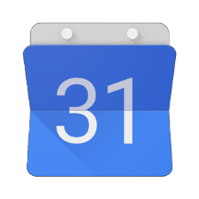

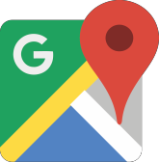

**G - site Canva**

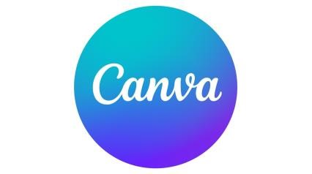

**Capcut**



**G**

**-**

**Sheets**

**Figma**

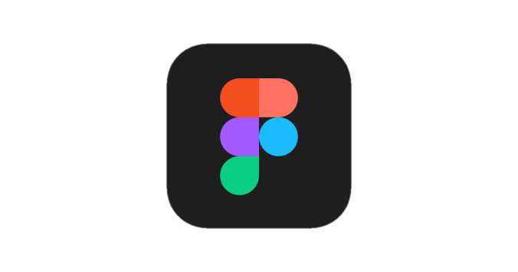

**G**

**m**

**a**

**il**



**G**

**-**

**Drive**



**G**

**-**

**Calendar**



**G**

**-**

**Maps**



**G**

**-**

**Forms**

**Capcut**

**Canva**



**G**

**-**

**Sheets**

**Figma**

**G**

**-**

**site**



S1

S2

S3

S4



**Note**: G = Google

## SESSION 1

* Each student needs to **pick up** one app

**5**

**PEOPLE PER GROUP**

**Original group**



* They are working(searching) **individually** on their own **app**

## SESSION 1



**5 PEOPLE PER GROUP**

* Come to the **expert group**



* **Explain** and share what you have **searched**

with your **expert memberExpert group**

* Make sure **everyone** in the **expert group** was **very clear** about the **app**
* Each expert group needs to **create** their own **quiz** (5-10 **questions** at least)



Note: Each question should be part of the apps that you plan to explain to your original member.

## SESSION 2

**5 PEOPLE PER GROUP**

* Each **student** in the **expert group** need to move to their **original group**
* Each **student** need to share what they **Original group knew** or **understood** about their own app from the **expert group** to the member of the **original group**

**How to share in group?**



**Original group**

**Round 2**



✓

Each

student has 10 mins

**presentation**

and 5

mins for

**questions**



**Original group**

**Round 1**



## SESSION 3 (Quiz)



### Quiz

**Schedule:**

**Capcut**



**G**

**-**

**Sheets**

**Figma**

**G**

**-**

**site**



**Canva**



**G - Maps G - Calendar G - Forms**



**G**

**m**

**a**

**il**



**G**

**-**

**Drive**

